TBUK Quality Mark™ Application 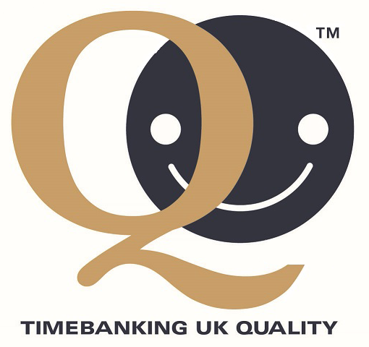

Timebanking UK Quality Mark™ is awarded to time banks over a year old that demonstrate best practice and who adhere to the core values of timebanking. It rewards the hard work of time banks while acting as public recognition of their high operational standards. To gain the award, time banks must demonstrate that they have achieved each of a list of criteria.

Once awarded, the Quality Mark™ is valid for three years. Holders can over the three years use the Quality Mark™ logo on their administrative and publicity materials, and they may also appear on the TBUK website and social media. TBUK may undertake random quality audits at any time during the three years to ensure standards are being maintained. At the end of the duration, a renewal application will need to be made.

Name of time bank

Address

Phone number
Email
Name and role of person completing form
How many members do you currently have? Although this may be an estimate, please make it as accurate as possible. | Individual Active ….. Inactive …….  Organisational Active … Inactive …….
Tell us about the broker or coordinator of your time. For example, is it shared? Paid or voluntary? If paid, where do the funds come from?

Please tell us the date your time bank started operating.
Are you part of a timebanking network with other satellite time banks or hubs? If yes, please briefly outline.

What legal structure does your time bank have? | Community group with charitable aims  CIC  Registered charity  Limited company  Social enterprise  Other ……………………………………………….
Does your time bank aim to work with a particular group of people (eg older or young people, ex-offenders)?
Does your time bank have stated aims and objectives? If so, what are they?

Do you use Time Online 2?
If not, how do you record exchanges?

Have you or your members undertaken TBUK broker training and/or other TBUK training? If so, when?
Have you undertaken any other training or professional development? If so, please describe this along with the date undertaken.
How is the time bank managed (eg board of Trustees, cooperative, sub-division of another voluntary or statutory service)?
Do you work in partnership with other organisations? If so, please name them and briefly describe the nature of your relationship.

Do you have a long-term sustainability plan?
Please describe it briefly or attach an outline.

Does your time bank use co-production, involving its members in the development and running of the time bank? | If yes, please give an example:
Do you monitor and evaluate your time bank? How?
Tell us a little about your financial structure (for example, are your accounts audited? Do you have a finance policy?)
Are you happy to be audited at any time during the three year period?
Do you have the following policies and procedures:

  - Health & Safety Yes/No
  - Equality & Diversity Yes/No
  - Confidentiality & Data Protection Yes/No
  - Safeguarding Yes/No
  - Complaints Yes/No
  - Support/supervision for time bankers Yes/No
  - Whistleblowing Yes/No
  - Environmental policy Yes/No

Please email copies to support this application.

Signature:

Date:

APPROVED FOR QUALITY

TBUK Signature:

Name:

Position:

Please return your completed application to:

nicki@timebanking.org

On receipt and approval by the board of trustees, we will return this form with our approval signature plus a separate document which will give you use of the Quality Mark™ logo.

Please write a short paragraph describing your time bank that we could use for publicity purposes.

