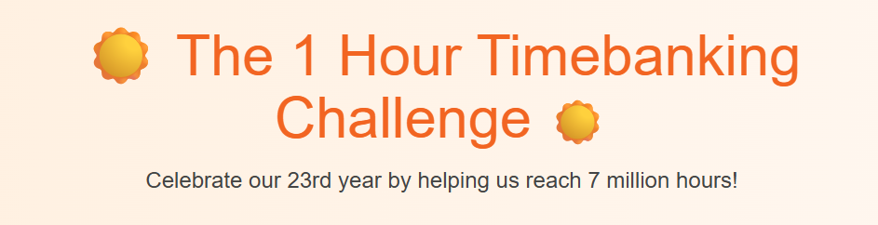

**What is timebanking?**

Timebanking is a bit different to volunteering because it is about giving AND receiving time. Sharing things that you can do and helping another person who might feel lonely. Everyone’s hour is the same and there is no monetary value placed on anything that people do. You can swap time remotely or you can meet up with someone who might live near you.

It is important to **fill in the joining questions**. Your answers will be confidential – no-one will see anything about you unless you tell them. The information is just for us at Timebanking UK to see who is swapping time with whom, where and how.

We will get in touch with you after you join if we need to because keeping everyone safe is paramount to us.

If you feel you are vulnerable, let us know in the joining questions and we can support you – remember, no-one will see your answers – only us at Timebanking UK.

**Contact us**

Our direct emails for this national time bank are John ([john@timebanking.org](mailto:john@timebanking.org)) and Sarah ([sarah@timebanking.org](mailto:sarah@timebanking.org)) or you can phone 01453 750952.

What kinds of things can you do as part of the 1 hour challenge?

There are thousands of ways that people swap time across the country such as: Chatting over the phone, giving language help, teaching someone to play a musical instrument, sharing cooking recipes, talking about a book or helping someone learn to paint or with art techniques.

If there are people near you, you might want to meet up. Check with us for advice and guidance on keeping safe.

Group activities are a favourite amongst time banks with walking groups, dog walking and gardening. Community social get togethers help alleviate loneliness and enable you to meet like-minded people to create new friendships.

**Safety First**

Timebanking UK will monitor all activities and intervene if something does not look right. If you want to report anything, use [info@timebanking.org](mailto:info@timebanking.org) and we will reply with urgency.

When you join put as much information about yourself onto your profile so that others can get to know you.

You will sign up to our data policy and our terms of service. We will send you a Handbook which contains frequently asked questions, how to log a complaint and tips on keeping safe.

We have insurance and will adhere to all national guidance on safety and minimising risk.

**But, please do take the challenge, do the time swap, log your hours and most of all, have fun!**

**Welcome to the world of timebanking!**